UNITED STATES

SECURITIES AND EXCHANGE COMMISSION
Washington, D.C. 20549

SCHEDULE 14A

Proxy Statement Pursuant to Section 14(a) of the
Securities Exchange Act of 1934 (Amendment No. )

Filed by the Registrant [X]
Filed by a party other than the Registrant [ ]

Check the appropriate box:
[ ] Preliminary Proxy Statement
- ]Confidential, for Use of the Commission Only (as permitted by Rule 14a-6(e)(2))
- ]Definitive Proxy Statement
- Definitive Additional Materials

[ ] Soliciting Material Under §240.14a-12

Capital One Financial Corporation

(Name of Registrant as Specified In Its Charter)

(Name of Person(s) Filing Proxy Statement, if other than the Registrant)

Payment of Filing Fee (Check the appropriate box):

- No fee required.

- ]Fee computed on table below per Exchange Act Rules 14a-6(i)(1) and 0-11.

  - Title of each class of securities to which transaction applies:

  - Aggregate number of securities to which transaction applies:

  - Per unit price or other underlying value of transaction computed pursuant to Exchange Act Rule 0-11 (set forth the amount on which the filing fee is calculated and state how it was determined):

  - Proposed maximum aggregate value of transaction:

  - Total fee paid:

[ ] Fee paid previously with preliminary materials.

- ]Check box if any part of the fee is offset as provided by Exchange Act Rule 0-11(a)(2) and identify the filing for which the offsetting fee was paid previously. Identify the previous filing by registration statement number, or the Form or Schedule and the date of its filing.

  - Amount Previously Paid:

  - Form, Schedule or Registration Statement No.:

  - Filing Party:

  - Date Filed:


Your Vote Counts!

CAPITAL ONE FINANCIAL CORPORATION

2022 Annual Stockholder Meeting

Vote by May 4, 2022 11:59 PM ET. For shares held in a Plan,

vote by May 2, 2022 11:59 PM ET.



CAPITAL ONE FINANCIAL CORPORATION

1680 CAPITAL ONE DR.

MCLEAN, VA 22102-3491

D73709-P62951-Z81181

You invested in CAPITAL ONE FINANCIAL CORPORATION and it’s time to vote!

You have the right to vote on proposals being presented at the Annual Stockholder Meeting. This is an important notice regarding the availability of proxy material for the stockholder meeting to be held on May 5, 2022.

Get informed before you vote

View the Proxy Statement and Annual Report to Stockholders/10-K online OR you can receive a free paper or email copy of the material(s) by requesting prior to April 21, 2022. If you would like to request a copy of the material(s) for this and/or future stockholder meetings, you may (1) visit www.ProxyVote.com, (2) call 1-800-579-1639 or (3) send an email to sendmaterial@proxyvote.com. If sending an email, please include your control number (indicated below) in the subject line. Unless requested, you will not otherwise receive a paper or email copy.


Smartphone users |  | Vote Virtually at the Meeting*
Point your camera here and |  | May 5, 2022
vote without entering a |  | 10:00 a.m. Eastern Time
control number
 |  | Virtually at:
 |  | www.virtualshareholdermeeting.com/COF2022



* Many stockholder meetings have attendance requirements. Please check the meeting materials for any special requirements for meeting attendance.

V1

Vote at www.ProxyVote.com

THIS IS NOT A VOTABLE BALLOT

This is an overview of the proposals being presented at the upcoming

stockholder meeting. Please follow the instructions on the reverse side to

vote these important matters.

Board

Voting Items Recommends
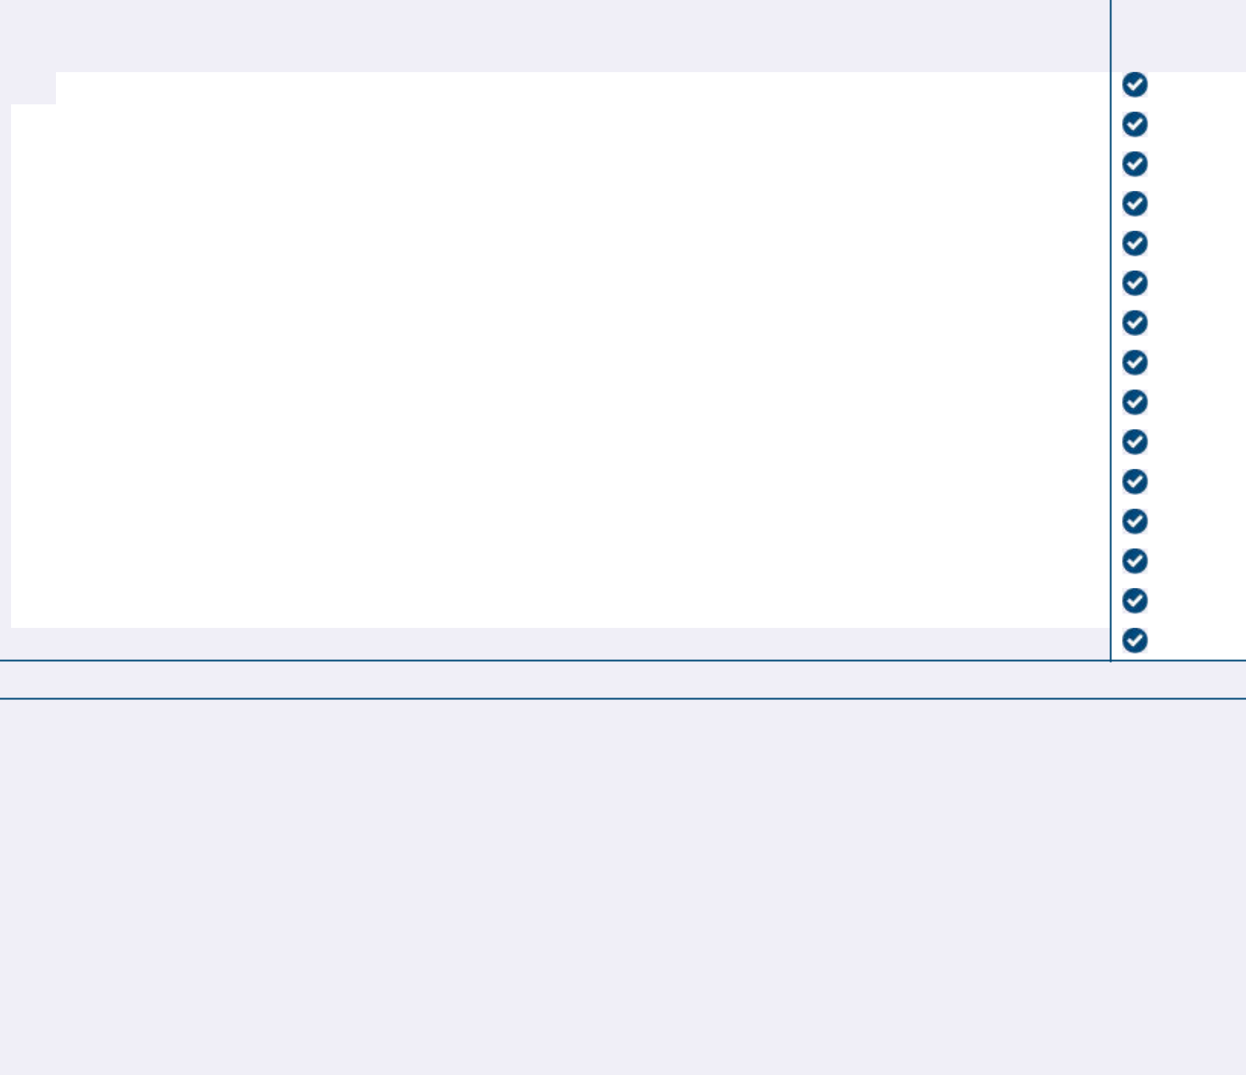

- Election of Directors

Nominees:

 | 1a. | Richard D. Fairbank | For
 | 1b. | Ime Archibong | For
 | 1c. | Christine Detrick | For
 | 1d. | Ann Fritz Hackett | For
 | 1e. | Peter Thomas Killalea | For
 | 1f. | Cornelis “Eli” Leenaars | For
 | 1g. | François Locoh-Donou | For
 | 1h. | Peter E. Raskind | For
 | 1i. | Eileen Serra | For
 | 1j. | Mayo A. Shattuck III | For
 | 1k. | Bradford H. Warner | For
 | 1l. | Catherine G. West | For
 | 1m. | Craig Anthony Williams | For
 | 2. | Advisory approval of Capital One’s 2021 Named Executive Officer compensation. | For
 | 3. | Ratification of the selection of Ernst & Young LLP as independent registered public accounting firm of Capital One for 2022. | For

NOTE: Such other business as may properly come before the meeting or any adjournment or postponement thereof.

Prefer to receive an email instead? While voting on www.ProxyVote.com, be sure to click “Sign up for E-delivery”.

D73710-P62951-Z81181

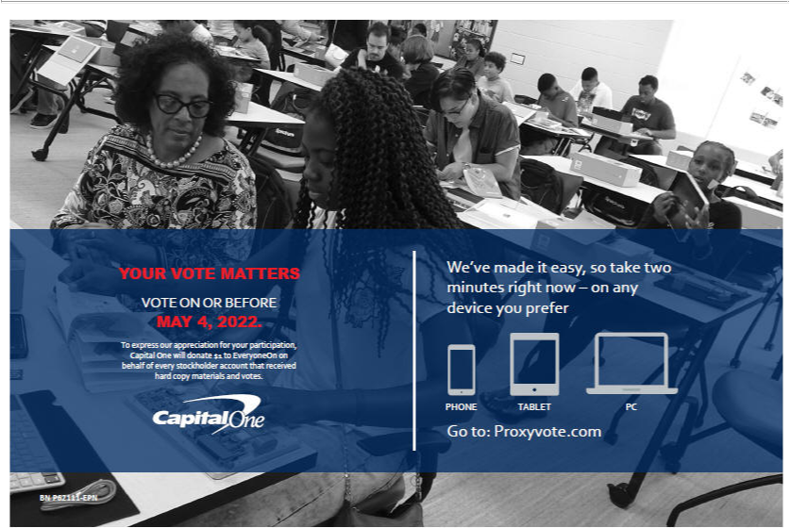


Frequently Asked Questions

Why am I receiving this Notice of Internet Availability?

The Securities and Exchange Commission (“SEC”) permits companies to send the enclosed “Notice” instead of a full printed set of proxy materials. The Notice provides instructions on how to view your company’s proxy materials, vote online and request a full set of printed materials by mail.

There are several advantages to your company sending a Notice instead of a full set of materials, including lowering your company’s costs and reducing the environmental impact from printing and mailing full sets of proxy materials.

How do I view the proxy materials online?

Go to www.proxyvote.com and enter your control number to get started. Your control number can be found on the enclosed Notice.

What if I prefer to receive a paper copy of the proxy materials?

You can easily request a paper copy which will be mailed to you at no cost. Instructions on how to do so can be found in the Get informed before you vote section of the Notice.

Can I receive proxy materials for future meetings by e-mail rather than receive a Notice?

Yes you can. Go to www.proxyvote.com and select “Email” in the Delivery Settings section.

For more information about the SEC’s Notice and Access Proxy Rules please visit:
www.sec.gov/spotlight/proxymatters/e-proxy.shtml.

